Use of the ISO 19100 Quality standards at the NMCAs

Results from a questionnaire

Expert group on Quality


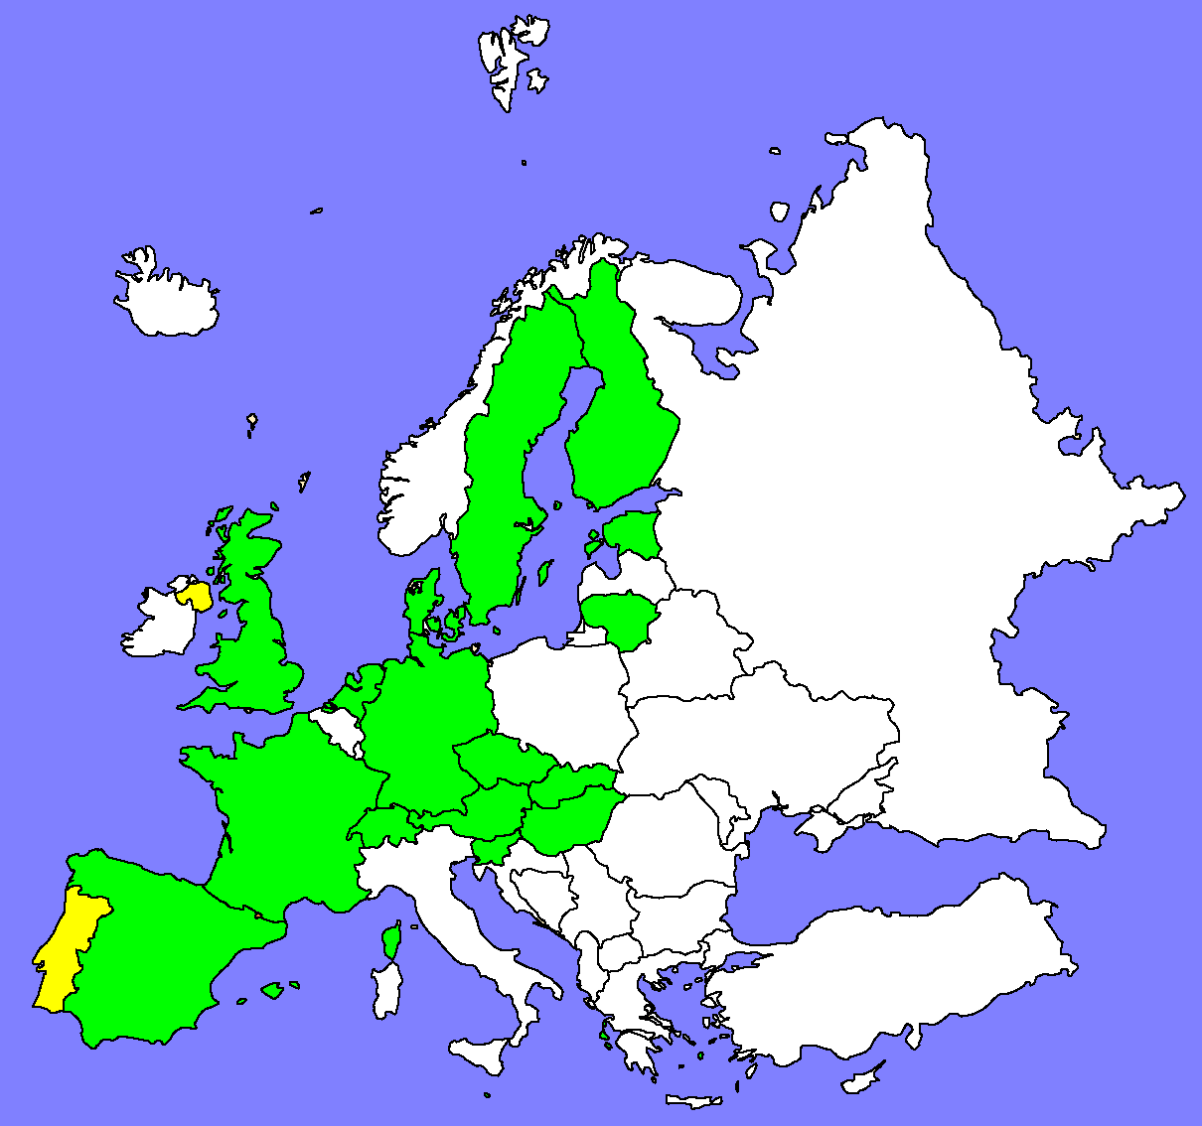
Reference:
History
Version | Author | Date | Comments
Draft 1 | Christina Wasström | 2004-06-11 | First draft
Draft 2 | Christina Wasström | 2004-10-05 | Added the result and the summary
Draft 3 | Christina Wasström | 2004-10-12 | Miner adjustment in the appendix
Draft 4 | Antti Jakobsson | 2004-12-15 | Some modifications
V 1.0 | Christina Wasström | 2004-12-17 | Resolve one comment.

File name: | 0000.doc
Keywords | ISO 19113, ISO 19114, ISO 19115, NMCAs, Standards, Utilization, Data quality, Metadata, Evaluation
Abstract | Report of the use of quality related ISO 19100 standards at the NMCAs. Mostly NMCAs are utilizing parts of the standards. The Expert Group on Quality will develop a guideline how to start using these standards.
Distribution: | Public
Approved by | Antti Jakobsson | Date : | 2004-12-15

Executive Summary

EuroGeographics vision is to achieve interoperability of European mapping and other GI data. To achieve interoperability of geographic information the use of standards is one important issue. In November 2003 the Expert Group on Quality decided that an inquiry about if the member countries were using the following standards was to be carried out;

- ISO 90113 Quality principles
- ISO 90114 Quality evaluation procedures
- ISO 90115 Metadata

The purpose was to get a quick overview of the situation. Therefore the questionnaire was sent only to the members of the Expert Group on Quality and not to all EuroGeographics members.
The result shows that just a few countries can say “yes, we are using the ISO standards”, but still, many countries are partly using the ISO 19100 standards. When the result was presented at the plenary meeting, the reasons for not implementing the standards were discussed. Some of the reasons given at that meeting were that several countries have problems to adopt the standard, because of the complexity of the standard and due to management; other activities are given priority. There is a willingness to adopt standards, but it is difficult to know were to begin. In trying to help more members to start to use the standards a workshop was held in October this year. The object was to point out guidelines how to start using the ISO 19100 standards within the datasets among the members.

Table of content
1 Executive Summary 2
2 Table of content 4
3 Background 4
4 Scope of the ISO 19100 series 4
4.1 ISO 19113 Quality principles 4
4.2 ISO 19114 Quality evaluation procedures 5
4.3 ISO 19115 Metadata 5
5 Result from the questionnaire 5
5.1 Introduction 5
5.2 Using ISO 19113 5
5.3 Using ISO 19114 7
5.4 Using ISO 19115 8
5.5 Documentation 10
6 Future work 10
7 Appendix 12
7.1 Questionnaire 12
7.2 Result ISO 19113 13
7.3 Result ISO 19114 14
7.4 Result ISO 19114 15

Background

At the plenary meeting with EuroGeographics (EGG) expert group of quality in November 2003 it was decided that a questionnaire concerning member countries use of standards was to be carried out. It was also decided that the questionnaire only would be sent to the members of EGGs expert group in quality (EGQ). The main objective was to make a rather quick investigation if the counties that are members of EGQ are using ISO 19100 standards or not and if any of these countries had some document that could help others with implementing the standards. The scope for the questionnaire was to find out the use of ISO standard 19113 (quality principles), 19114 (quality evaluation procedures) and 19115 (metadata).
Dolors Barrot and Christina Wasström wrote the questionnaire, Christina Wasström analysed the answers. The result was presented and discussed at the plenary meeting in May 2004.

Scope of the ISO 19100 series

ISO 19113 Quality principles

This standard establishes the principles for describing the quality of geographic data and specifies components for reporting quality information. It also provides an approach to organising information about data quality. The standard is applicable to data producers providing quality information to describe and assess how well dataset meets its mapping of the universe of discourse as specified in the product specification. It is also applicable to data users attempting to determine whether or not specific geographic data is sufficient quality for their particular application.

ISO 19114 Quality evaluation procedures

This standard provides a framework of procedures for determining and evaluating quality that is applicable to digital geographic datasets, consistent with the data quality principles defined in ISO 19113. It also establishes a framework for evaluating and reporting data quality results, either as part of data quality metadata only, or as an evaluation report.

ISO 19115 Metadata

This standard defines the schema required for describing geographic information and services. It provides information about the identification, the extent, the quality, the spatial and temporal schema, spatial reference, and distribution of geographic data.

Result from the questionnaire

Introduction

The EuroGeographics expert group of quality had, at the time for the investigation (May 2004), seventeen member countries. The following countries answered the questionnaire; Austria, Czech republic, Denmark, Estonia, Finland, France, Great Britain, Germany The Netherlands, Hungary, Lithuania, Slovakia, Slovenia, Spain and Sweden. Only answers from two countries were missing.
The main reason with the questionnaire was to get a hint of if and which NMCA's were using the quality standards so that the expert group could go on with the next step; to spread good practices among the members on how to implement standards. Therefore the questionnaire had a rather simple design, there was a choice to answer yes or no. Beside the yes or no answer, there was also a possibility to add some comments. When reading the comments, it was obviously that several answers were somewhere “in between”. Therefore some of the answers were adjusted; these answers were moved from the yes- and no-category to a new category called partly.

Using ISO 19113

After compiling the result from the first answer; “Are your NMA using ISO 19113 (Quality principles)?” the answers were almost divided equally.
Table A. Use of ISO 19113 (original answers)
Standard | Yes % | No %
ISO 19113 | 47 | 53

When the comments where analysed, it was obvious that the number of countries which had answered no could be reduced. Several countries are using the standard partly in some way. Here are some examples of comments that changed some of the original answers to partly. The original answers are in brackets;
- “More no than yes, but it was used for creation of data quality model of topographical basic map.” (No)
- “Use the standard ENV 12656:1999 which has been mostly included in ISO 19113”. (No)
- “Some of our datasets have acceptable quality levels that are based upon the ethos of the ISO standard.” (No)
- “No direct use, but the principles of it is taken in account.” (No)
- “Not entirely” (Yes)
- “Partly, under development.” (Yes)
- “Used the standard to support the evaluation of the conversion software.” (Yes)
- “Parts of the standard were used when creating a new conceptual data model.” (Yes)

When the comments were included and the answers were divided into three categories it shows that most of the countries are using the ISO standard 19 113 in some way. Just 20 per cent of those who answered the questionnaire are not using the standard.

Table B. Use of ISO 19113 standard (analysed)
Standard | Yes % | No % | Partly %
ISO 19113 | 20 | 20 | 60

When combining the yes- and the partly-answers, it was clear that most of the countries have at least starting to use the standard, see Figure 1.
ISO 19113
0
10
20
30
40
50
60
70
80
90
No
%
Yes/Partly
Figure 1. Result from question related to ISO 19113

Using ISO 19114

After compiling the result from the second answer; “Are your NMA using ISO 19114 (Quality evaluation procedures)?”, there majority of the countries answered no.

Table C. Use of ISO 19114 (original)
Standard | Yes % | No %
ISO 19114 | 40 | 60

When the comments where analysed, it was obvious that the number countries which had answered no could be reduced to half. Here are some examples of comments that changed some of the original answer to “partly”. The original answers are in brackets;
- “More no than yes, but it was used for creation of data quality model of topographical basic map.” (No)
- “Some of our quality evaluation is based upon the ethos of this standard.” (No)
- “No direct use, but the principles of it is taken in account.” (No)
- “Partly, under development.” (Yes)
- “Not entirely” (Yes)
There were more direct answers to this question, not as many comments from the countries as in the first question.

Table D. Use of ISO 19114 (analysed)
Standard | Yes % | No % | Partly %
ISO 19114 | 27 | 33 | 40

When adding the comments the result show that even if many countries are beginning to use the ISO standard 19 114, as much as 1/3 of the countries are not using it, see Figure 3.
ISO 19114
0
10
20
30
40
50
60
70
80
90
No
%
Yes/Partly
Figure 2. Result from question related to ISO 19114.

Using ISO 19115

After compiling the result from the third answer; “Are your NMA using ISO 19115 (Metadata)?”, there were more countries which answered yes then countries which answered no.

Table E. Use of ISO 19115 (original).
Standard | Yes % | No %
ISO 19115 | 60 | 40

When the comments where analysed, the number of no-answers could be reduced to more than a half. Here are some examples of comments that changed some of the original answer to “partly”. The original answers are in brackets;
- “Partly”. (Yes)
- “Partly, still undergoing revision” (Yes)
- “The new metadata service will be based on the standard” (Yes)
- “A working group is studying how to implement the standard” (Yes)
- “No direct use, but the principles of it is taken in account.” (No)
- “Partly, under development.” (Yes)
- “Partly, still in testing phase” (Yes)
- “Not entirely” (Yes)
- “Planning on building a new metadata system based on the standard” (No)
There were many comments to this third question. The conclusion is that many countries are starting to create new services for metadata and that the systems will be based on the ISO 19115 standard.

Table F. Use of ISO 19115 (analysed)
Standard | Yes % | No % | Partly %
ISO 19115 | 13 | 27 | 60

Even when the yes- and the partly-answers were combined there were several countries that don’t use or plan to use the standard, see Figure 3.

ISO 19115
0
10
20
30
40
50
60
70
80
90
No
%
Yes/Partly
Figure 3. Result from question related to ISO 19115.

Documentation

Beside the questions about if the members were using the standards, there were also questions about documentation. The purpose with those questions was to find out if the members had any documentation on how the standard was implemented or if the had any other reference document that could be useful to others.
There was only one country (Germany), which had documentation about how the standard was implemented. The document is available on the Internet http://www.advonline.de/dokumente/geoinfodok-eng-v30.pdf
A couple of other countries mention that they had other reference document, which was partly translated into English.

Future work

At the plenary meeting in May 2004 it was decided to arrange a workshop concerning the use of the ISO 19100 standards within the national mapping and cadastral agencies. The goal was to develop guidelines for starting the use of ISO 19100 standards within our datasets. This workshop was held in September 2004. At the workshop, following draft table of content for the guidelines were agreed:
- Introduction
- The ISO 19100 series
- How does the standard applies within the NMCA’s datasets
- The NMCA’s experiences so far (case studies)
- The summery of findings
  - Common profile <-> dataset profile
  - Solving the interpretation challenge
  - The organisational issue
  - Co-operation within the NAMCO
  - Communication and training
  - Develop XML schema for each profile
  - Need for common Eurogeographics profiles
- The use of the Quick analysis tool
- Strategic fit (business need, stakeholder, customer need, operational impact)
- Risk analysis impact
- Achievability and affordability, what kind of resources, expertise, technology, time lapse, competence
- Availability of data
- Benefits (tangible, intangible)
- Conclusion and recommendations

Appendix

Questionnaire

Use of ISO 19100 Geographic information quality standards

EuroGeographics expert group of quality is creating a “knowledge bank” on the website where EuroGeographics members can get information about quality issues. In order to find interesting documents about how to implement international standards, the expert group hopes that you can answer the following questions.
The main purpose with a standard is to be able to exchange data, so the word “implement” could mean both how to change your own data into the ISO standard or just to make it possible to communicate with another dataset.
If you have decided not to use a standard, please add your reasons in the column for comments.

 | YES | NO | Comments
Are your NMA using ISO 19113 (Quality principles)?
Are your NMA using ISO 19114 (Quality evaluation procedures)?
Are your NMA using ISO 19115 (Metadata)?
Do you have reference documents that describe how the standard was implemented
Do you have this reference documents in English
Do you have other reference documents that could be of an interest to other NMAs
Do you have this reference documents in English
Who is your contact person for issues concerning ISO 19100?

Result ISO 19113

ISO 19113
Yes
Partly
No
No answer
N
N
N
N
Y
Y
N
Y
Y

Result ISO 19114

ISO 19114
Yes
Partly
No
No answer
N
N
Y
N
N
Y

Result ISO 19115

ISO 19115
Yes
Partly
No
No answer
N
Y
Y
Y
N
Y
Y
Y
Y

